**Module Interface Specification For The Playback Control Module**

Brian Alexander

# Introduction

The output module is responsible for providing control of the Windows Playback Device.

# Requirements

## Services Provided By this Module to Its Users

|  |  |  |
| --- | --- | --- |
| Service | Provided By | Tested By |
| 1. Controls wave processing modules based on commands received from playback control form | Play, Pause, Stop, Next, Previous |  |
| 1. Provides stream of PCM data for output module | GetFrames |  |

## Requirements for Services Needed By The Module

The output module relies on the input module to provide an access method that returns a stream of PCM data.

# Exceptions

None

# Access Method Table

|  |  |  |  |  |  |
| --- | --- | --- | --- | --- | --- |
| **Exceptions : None** | | | | | |
| **Access Methods** | **Parameter name** | **Parameter type** | **Parameter Info** | **Performance**  **Best - Worst** | **–Mapping to Services Provided** |
| Play |  |  |  |  | 1 |
| Pause |  |  |  |  | 1 |
| Stop |  |  |  |  | 1 |
| Next |  |  |  |  | 1 |
| Previous |  |  |  |  | 1 |
| GetFrames |  |  |  |  | 2 |

# Local Dictionary

## Parameter Terms

|  |  |
| --- | --- |
| **Parameter Term** | **Meaning** |
|  |  |
|  |  |

## Local Terms

|  |  |
| --- | --- |
| **Term** | **Meaning** |
|  |  |
|  |  |

## Local Conditions

|  |  |
| --- | --- |
| **Term** | **Meaning** |
|  |  |
|  |  |

## Local Data Types

|  |  |
| --- | --- |
| **Type** | **Value Space** |
|  |  |
|  |  |
|  |  |

# Access Methods Effects

The access methods that are called by the playback control form will control the playback control module like a state machine.

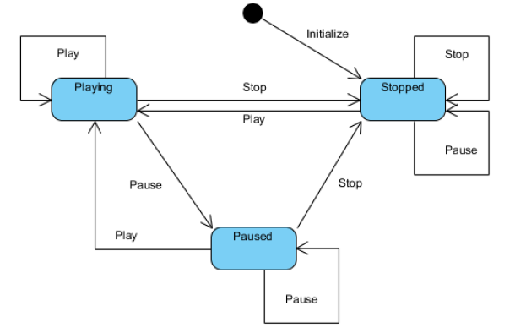

# Events Signaled

None

# Externally Visible States of the Module

Started or Stopped

# Module Configuration Parameters

None.

# Interface Design Issues

None

# Implementation Notes.

# Efficiency Guide

# Test Cases

# Questions for Reviewers

Reviewers of this module interface specification should answer the following questions as they think about the specification.

## Requirements Validity

1. For each service provided by the module, is the service valid for all expected uses of this module? If not, give an example of a use where the service is not valid. (Systems Engineer)
2. For each service provided by the module, is the service valid for all expected configurations and versions of this module? If not, give an example of a needed configuration or version where the service is not valid. (Systems Engineer)
3. For each service needed described in this specification, is a module (or set of modules) identified that this module is allowed to use to satisfy the need? (Architect, Tester)
4. Are there cases where the interface specification could not be satisfied or was incomplete+? If so, how should it be changed? (Architect)

## Requirements Sufficiency

1. Does the set of services provided specify all of the services that will be needed by users of this module? Are there any services defined that are not identified in the requirements? (Systems Engineer)
2. Does the set of services needed specify all of the services that this module will need from other modules in order to operate correctly? What services are needed that are not identified in the requirements? (Architect)

## Consistency Between Services Provided and Access Programs

1. For each Services Provided described in this specification, which access program(s) can be used to satisfy the service? (Architect , Developer, Tester)
2. For each access program and signal specified in sections and which Service Provided is satisfied by the access programs? (Architect , Developer, Tester)

## Access Program Adequacy

1. Is the set of access programs and signals, including exceptions, sufficient to satisfy the uses needs of modules that are allowed to use this module? (Architect)
2. Are there access programs that should be combined into one access program? (Developer)
3. Are there single access programs that should be refactored into several different access programs? (Developer)
4. Are the performance requirements adequate for the uses that will be made of this module? (Tester)

## Implementation of Variability

1. Which variability (or variabilities) does this module implement? (Systems Engineer)
2. Are all values in the range defined in the parameters of variation accounted for in implementing each variability? Which values are not? (Developer)
3. Can the variabilities be bound at the time specified in the commonality analysis for the variabilities? (Architect)